Problem Set 3

1. **(Total 25points)**Average accounting return (AAR)is an investment’s average net income divided by its average book value:   
   Let's consider the scenario of potentially opening a store in a new shopping mall. To proceed, we need to invest $750,000 in improvements. The store's operational life spans five years, after which all assets revert to the mall owners. For accounting purposes, the investment would be depreciated at a rate of 100% straight-line over five years, resulting in $150,000 depreciation annually. The applicable tax rate stands at 21%.

Fill in the unknow numbers, each box for 1 point. (20 points)

What is the AAR? (5 points)

|  |  |  |  |  |  |
| --- | --- | --- | --- | --- | --- |
|  | **Year 1** | **Year 2** | **Year 3** | **Year 4** | **Year 5** |
| Revenue | $ 500,000 | $ 450,000 | $250,000 | $200,000 | $ 150,000 |
| Expenses | 200,000 | 150,000 | 100,000 | 100,000 | 100,000 |
| Earnings before depreciation | $ xxxxx | $ xxxxx | $ xxxxx | $ xxxxx | $ xxxxx |
| Depreciation | 150,000 | 150,000 | 150,000 | 150,000 | 150,000 |
| Earnings before taxes | $ xxxxx | $ xxxxx | $ xxxxx | $ xxxxx | − $ xxxxx |
| Taxes (21%) | xxxxx | xxxxx | xxxxx | ___xxxxx | xxxxx |
| Net income | $ xxxxxxx | $ xxxxxxx | $ xxxxxxx | $ xxxxxxx | $ xxxxxxx |

1. **(Total 10 points)**The point where the NPV profiles intersect occurs approximately at an 9 percent discount rate. How can we precisely identify this crossover point? The crossover rate, defined as the discount rate that equalizes the NPVs of two projects, helps us in this regard. To illustrate, let's consider the following scenario with two mutually exclusive investments:  
   What is the crossover rate?

|  |  |  |
| --- | --- | --- |
| **Year** | **Investment A** | **Investment B** |
| 0 | −$200 | −$500 |
| 1 | 150 | 360 |
| 2 | 120 | 300 |

1. **(Total 15 points)**Suppose we require a 10% return on new investments. We have an investment that costs $300 and has cash flows of $100 per year for five years. To get the discounted payback, we have to discount each cash flow at 10% and then start adding them.

|  |  |  |  |  |
| --- | --- | --- | --- | --- |
| **Year** | **Cash Flow Undiscounted** | **Cash Flow Discounted** | **Accumulated Cash Flow Undiscounted** | **Accumulated Cash Flow discounted** |
| 1 | $100 | $xx | $100 | $ xx |
| 2 | 100 | xx | 200 | xx |
| 3 | 100 | xx | 300 | xx |
| 4 | 100 | xx | 400 | xx |
| 5 | 100 | xx | 500 | xx |

Fill in the unknow numbers, each box for 1 point. (10 points)

When is the discounted payback period? (5 points)

1. **(Total 30 points)**

This is an unconventional cash flow:   
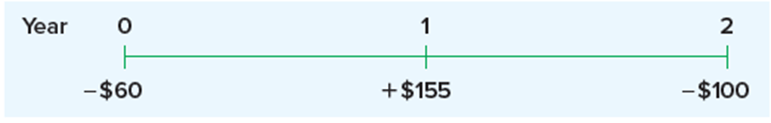  
What would be the adjusted cash flow and what is the Modified Internal Rate of Return (MIRR) if the project's required rate of return is 15%? Utilizing three distinct approaches—discounting, reinvestment, and combination—to compute the cash flow and MIRR, each method is worth 10 points.

-$100

+$170

-$90

1. **(Total 10 points)**Take into account a property typically categorized as 7-year property, with a price tag of $20,000. Utilize the MACRS to fill out the provided table.

|  |  |  |  |
| --- | --- | --- | --- |
| **Year** | **Beginning Book Value** | **Depreciation** | **Ending Book Value** |
| 1 | $20,000.00 | $ xxxx | $ xxxx |
| 2 | xxxx | xxxx | xxxx |
| 3 | xxxx | xxxx | xxxx |
| 4 | xxxx | xxxx | xxxx |
| 5 | xxxx | xxxx | xxxx |
| 6 | xxxx | xxxx | xxxx |
| 7 | xxxx | xxxx | xxxx |
| 8 | xxxx | xxxx | xxxx |

1. **(Total 10 points)**   
   Based on tax shield approach, what is the OCF if:

Sales=$2,000  
Costs=$500  
Depreciation$1000